**DRIVING SCHOOL**

**MANAGEMENT**

**SYSTEM**

***DONE BY:-***

***LUKKA SHIVA CHARAN***

***IT B***

***1602-19-737-103***

**1**

**ABSTRACT:**

The Driving School Management System is a web- based system that provides a single-stop for registration and maintenance of driving school database of Cherry Driving School (Name of driving school). The database consists of all the details of customer, details of staff allotted to a particular customer, registration status, payment with license or without license, vehicle number and number of class the customer has opted for. We provide online as well as offline registrations whereas classes are not virtual, there will be people who will approach at your specified address and pick you up and train you on a kilometer basis for one particular day. Driving School Management System (DSMS) is important for ensuring the correct operation of driving school and in maintaining the services that run on them. This project has total of 6 tables. It describes how the network is being connected all across the customers and the particular staff. When you enter the data, it is stored in the data base and is displayed whenever you need it. The data can be updated or changed only by the people of the driving school.

**2**

**REQUIREMENT ANALYSIS:**

List of tables:

* Customer_details
* Vehicle_time
* Further_details
* Staff_details
* Id_proofs & postal
* Payment_status

List of attributes with their domain types:

1.Customer_details:

Cust_Id: cust_id number (5)

C_name: C_name varchar2 (20)

Date of join: date of join varchar2 (20)

Licence_type: licence_type varchar2 (20)

Mobile_num: Mobile_num number(20)

Email_id: email_id varchar2 (20)

Address: Address varchar2 (20)

**3**

2.Vehicle_time:

Cust_name: cust_name varchar2(20)

Period: period varchar2(15)

Time of attending: time of attending varchar2 (20)

Vehcile_type: vehicle_type varchar2 (20)

Vehcile name: vehicle name varchar2 (20)

3.Further details:

Customer_id: customer_id number (5)

Course days: course days number (2)

Licence_required: Licence_required varchar2 (20)

Pickup Address: pickup address varchar2 (20)

4.Staff details:

Staff_id: staff_id number (5)

Person_Name: Person_name varchar2 (20)

Mobile_number: mobile_number number (15)

Email: email varchar2 (30)

Staff_add: Staff_add varchar2 (30)

5.Id_proofs& postal:

Person_id: Person_id number (5)

Name: name varchar2 (20)

Aadhar No: aadhar number (16)

Tenth_memo: tenth memo varchar (20)

Postal_Address: postal address varchar2 (20) **4**

6. Payment Status:

id: id number (5)

Customer_Name: customer_name varchar2 (20)

Total Money: total money number (5);

Money Paid: money paid number (5);

**5**

**MAPPING CARDINALITY AND PARTICIATION**

* **CONSTRAINTS**

The internet is connected to server. So, every servers connected to the internet, which is one to many participations. In this you can only opt for a one particular vehicle type at a time and the time of attending to driving classes cannot be changed once you are done with filling the form. You will be allotted one staff member who will pick you and drop you depending upon the pickup location. Your Id proofs are must in order to opt for a driving licence. You will receive licence only when your payment is completely done. For the driving registration you have two means i.e online and offline. Each computer will have only one operating system which is one to one participation.

**6**

ARCHITECTURE AND TECHNOLOGY

*Software used:*

Java Eclipse, Oracle 11g Database,Java SE version 13, SQL*Plus.Java

**AWT:**

Java AWT (Abstract Window Toolkit) is an API to develop GUI or window-based applications in java.Java AWT components are platform-dependent i.e. components are displayed according to the view of operating system. AWT is heavyweight i.e. its components are using the resources of OS.The java.awt package provides classes for AWT API such as TextField, Label, TextArea,RadioButton, CheckBox, Choice, List etc.

**SQL:**Structure Query Language(SQL) is a database query language used for storing and managing data in Relational DBMS. SQL was the first commercial language introduced for E.F Codd's Relational model of database. Today almost all RDBMS (MySql, Oracle, Infomix, Sybase, MS Access) use SQL as the standard database query language. SQL is used to perform all types of data operations in RDBMS.

**7**

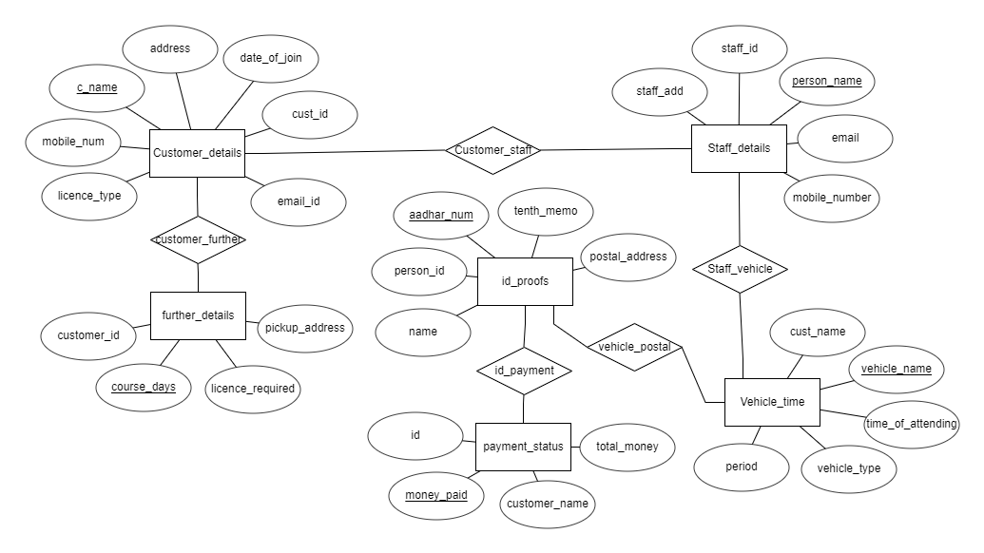

**8**

**DDL COMMANDS:**

1. create table **customer_details** (cust_id number (5), c_name varchar2(20) primary key, date_of_join varchar2(20), mobile_num number (20), email_id varchar2(30), address varchar2(30));
2. create table **vehicle_time** (cust_name varchar2(20), period varchar (15), time_of_attending varchar2(30), vehicle_type varchar2(20), vehicle_name varchar2(20) primary key);
3. create table **further_details** (customer_id number (5), course_days number (2) primary key, licence_required varchar2(20), pickup_address varchar2(30));
4. create table **staff_details** (staff_id number (5), person_name varchar2(20) primary key, mobile_number number (15), email varchar2(30), staff_add varchar2(30));
5. create table **id proofs** (person_id number (5), name varchar2(20), aadhar_num number (16) primary key, tenth_memo varchar2(20), postal_address varchar2(30));
6. create table **payment_status** (id number (5), customer_name varchar2(20), total_money number (5), money_paid number (5) primary key);
7. create table **customer_staff**(c_name varchar2(20), person_name varchar2(20), foreign key(c_name) references customer_details(c_name), foreign key(person_name) references staff_details(person_name));
8. create table **staff_vehicle** (person_name varchar2(20), vehicle_name varchar2(20), foreign key(person_name) references staff_details(person_name), foreign key(vehicle_name) references vehicle_time(vehicle_name));
9. create table **vehicle_postal** (vehicle_name varchar2(20), aadhar_num number (16), foreign key(vehicle_name) references vehicle_time(vehicle_name), foreign key(aadhar_num)

**9**

references id_proofs(aadhar_num));

1. create table **id_payment** (aadhar_num number (16), money_paid number (5), foreign key(aadhar_num) references id_proofs(aadhar_num), foreign key(money_paid) references payment_status(money_paid));
2. create table **customer_further** (c_name varchar2(20), course_days number (2), foreign key(c_name) references customer_details(c_name), foreign key(course_days) references further_details(course_days));

DML COMMANDS

1. insert into customer_details values(&cust_id,'&c_name','&date_of_join','licence_type',&mobile_num,'&email_id','&address');
2. insert into staff_details values(&staff_id,'&person_name',&mobile_number,'&email','&staff_add');
3. insert into vehicle_time values('&cust_name','&period','&time_of_attending','&vehicle_type','&vehicle_name');
4. insert into id_proofs values(&person_id, ‘person_name', &aadhar_num, '&tenth_memo', '&postal_addess');
5. insert into payment_status values (&id, '&customer_name', &total_money, &money_paid);
6. insert into further_details values (&customer id, &course_days, '&licence_required', '&pickup_address');

**10**

**OUTPUTS:**

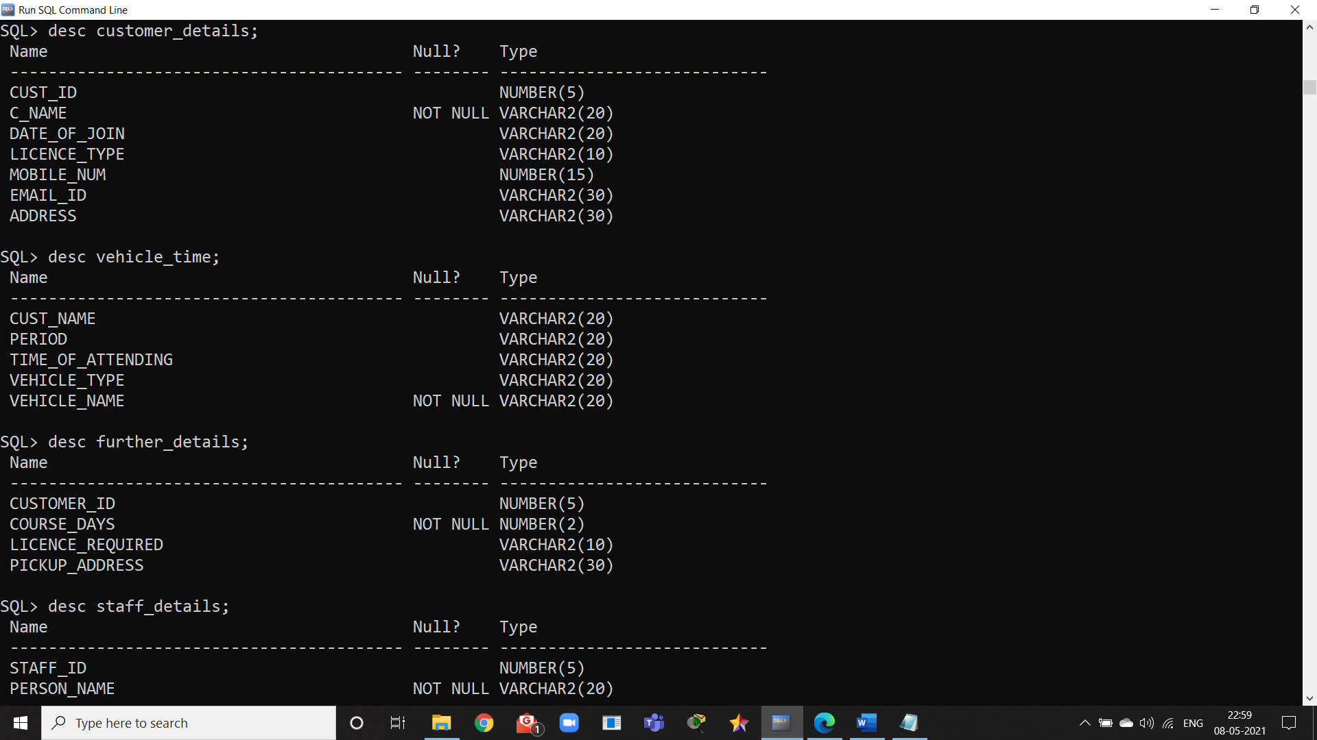

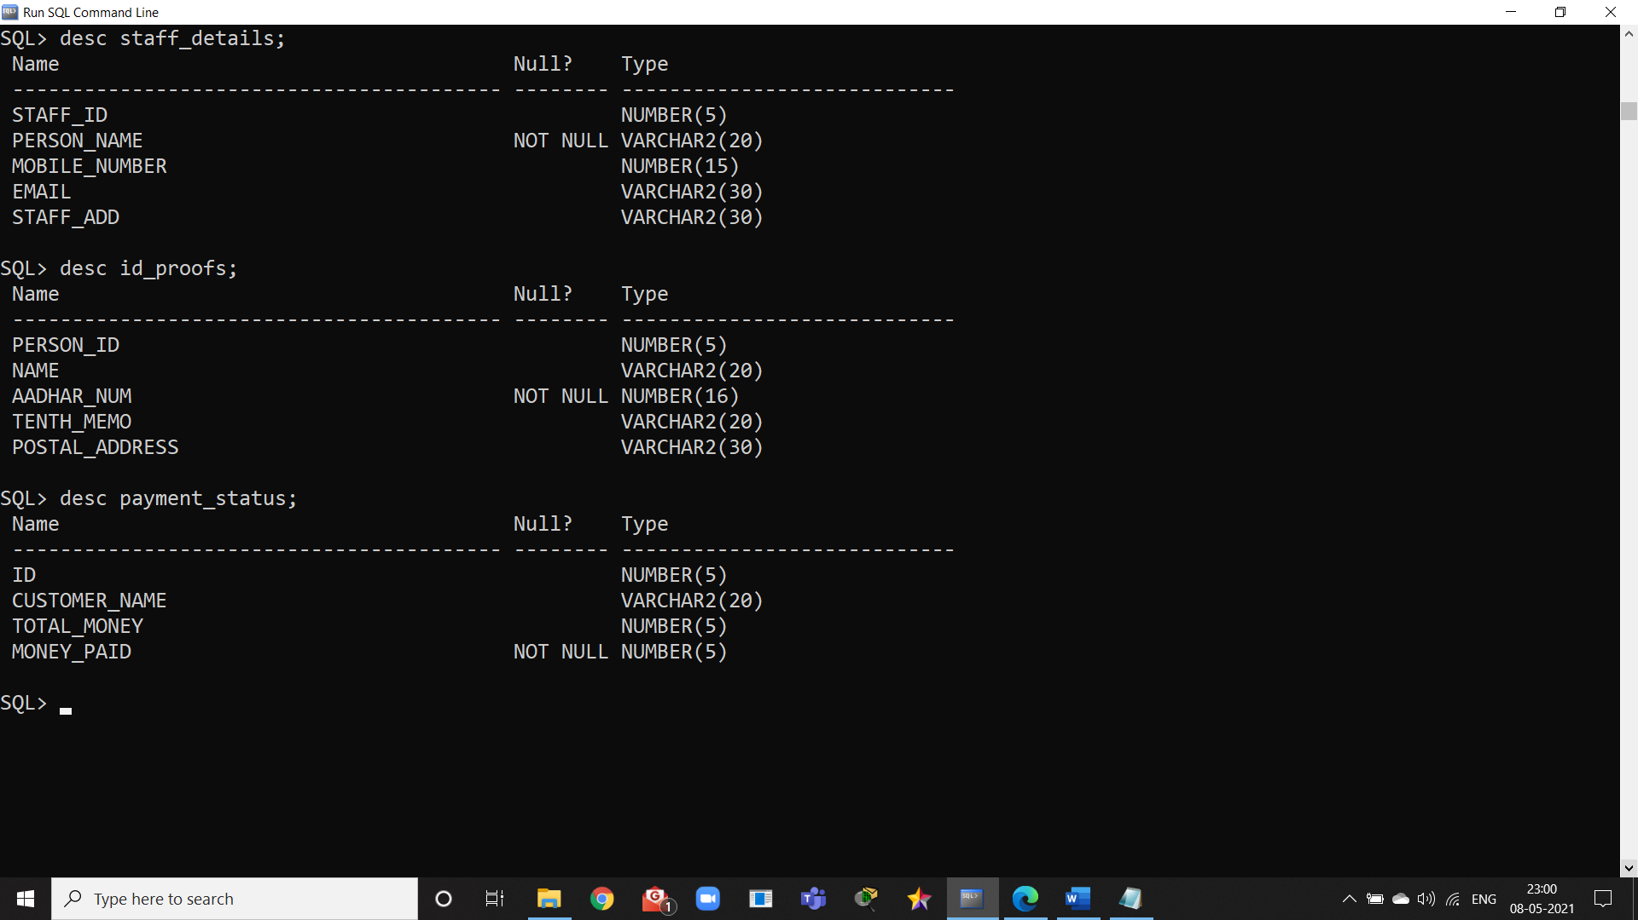

**11**

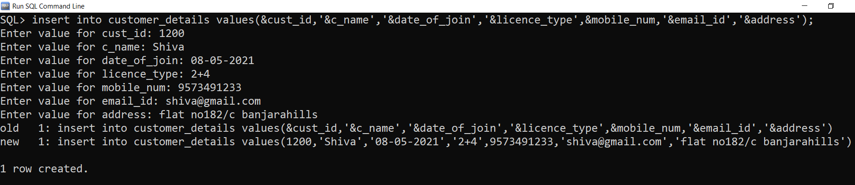

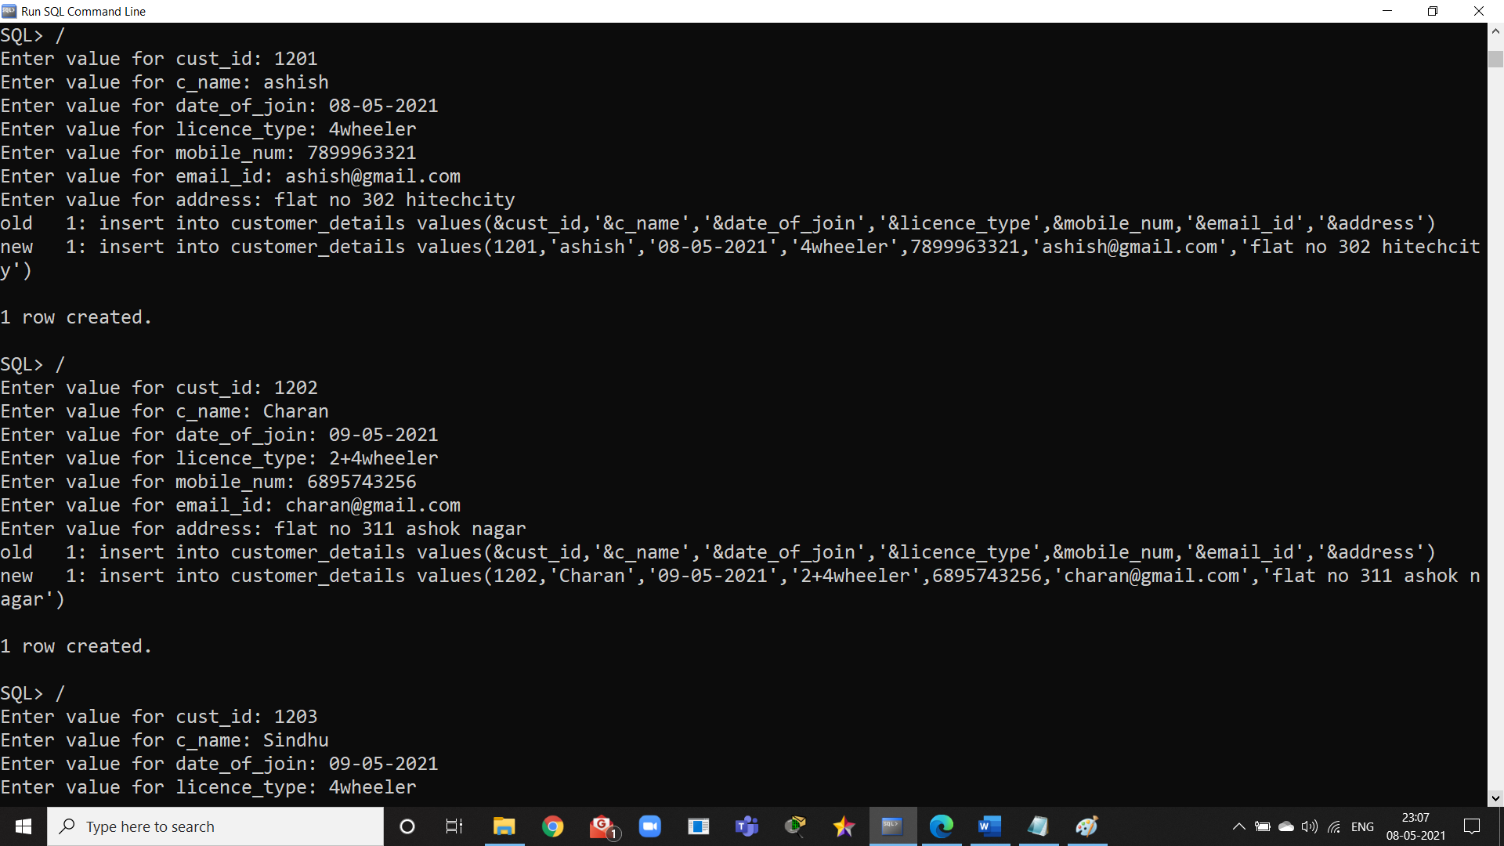

**12**

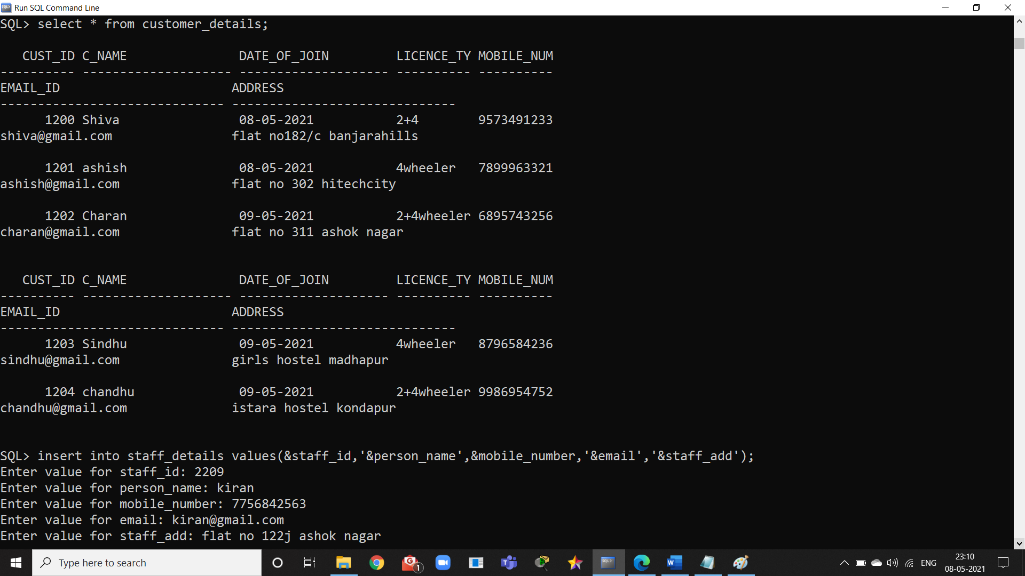

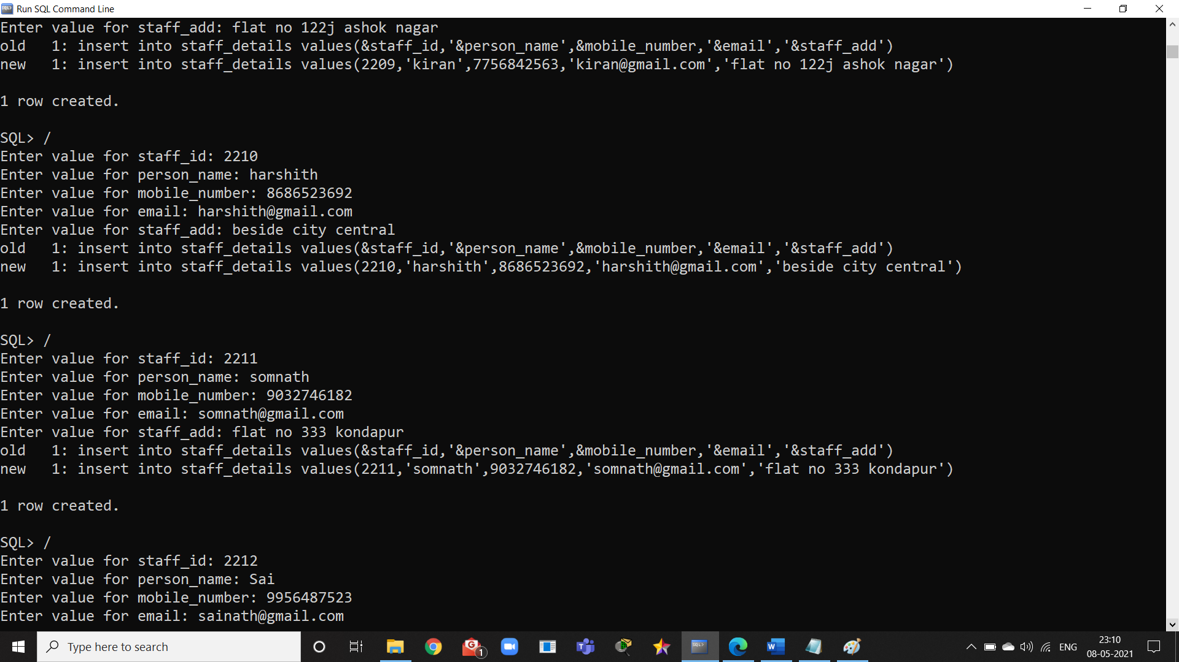

**13**

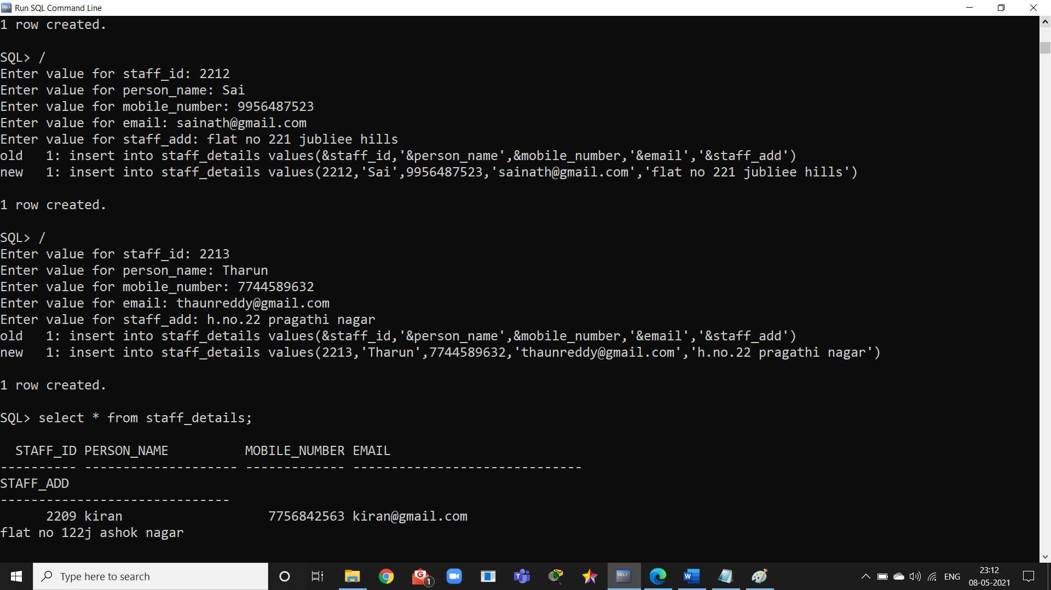

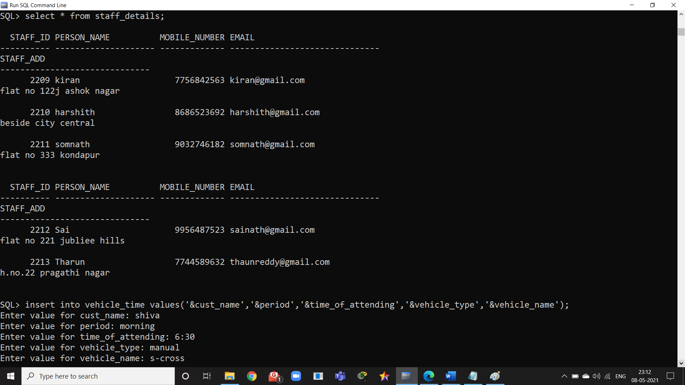

**14**

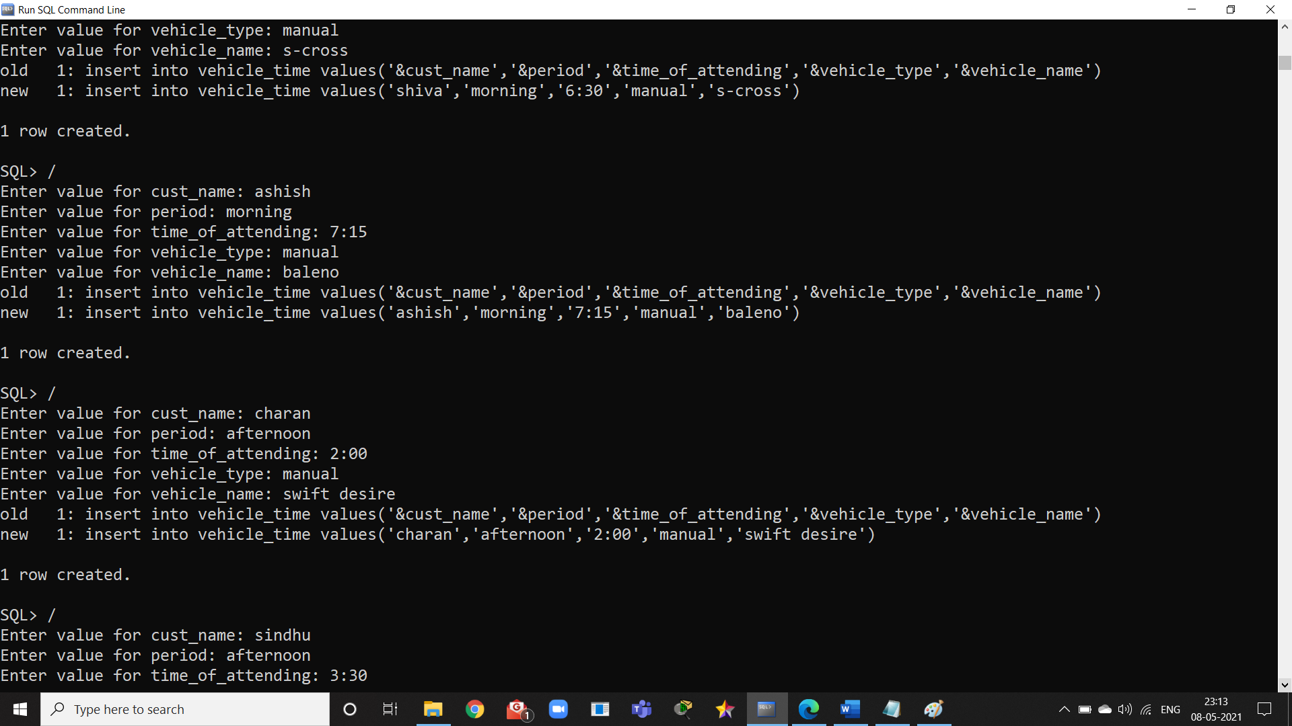

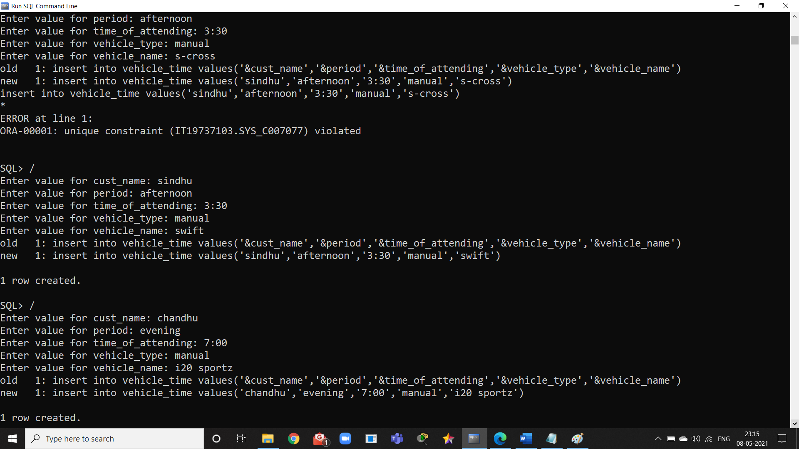

**15**

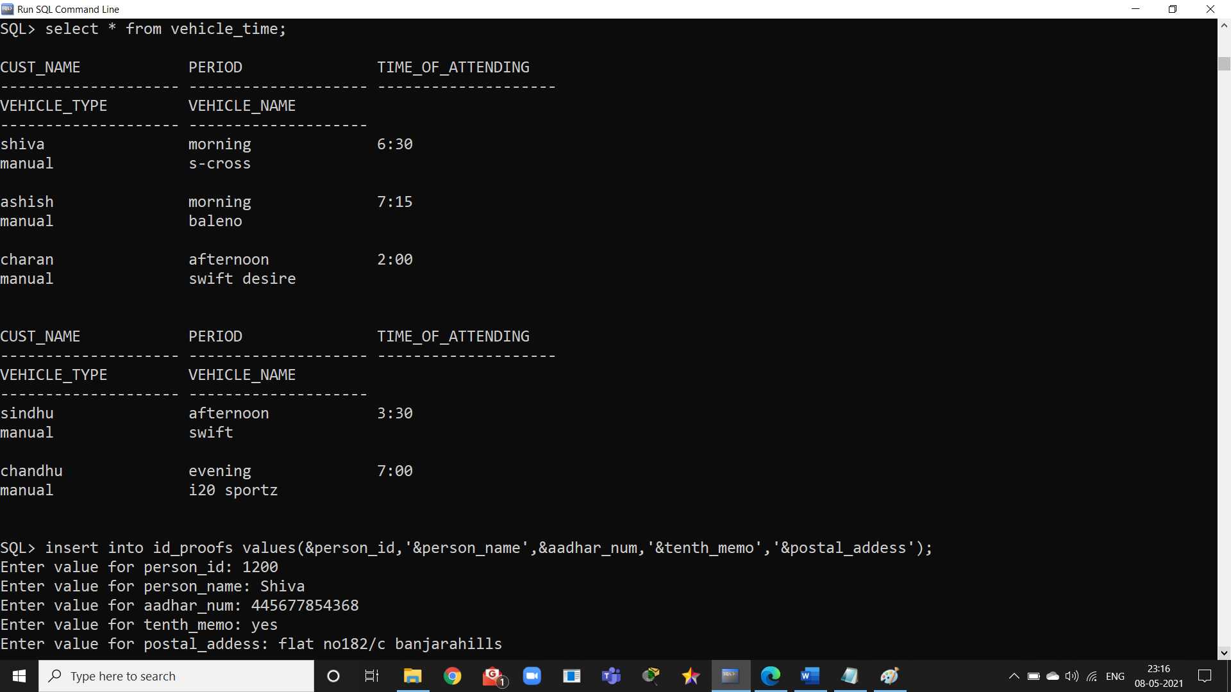

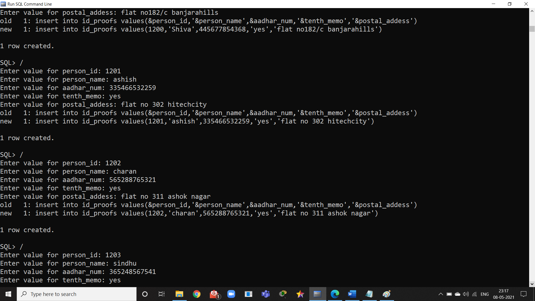

**16**

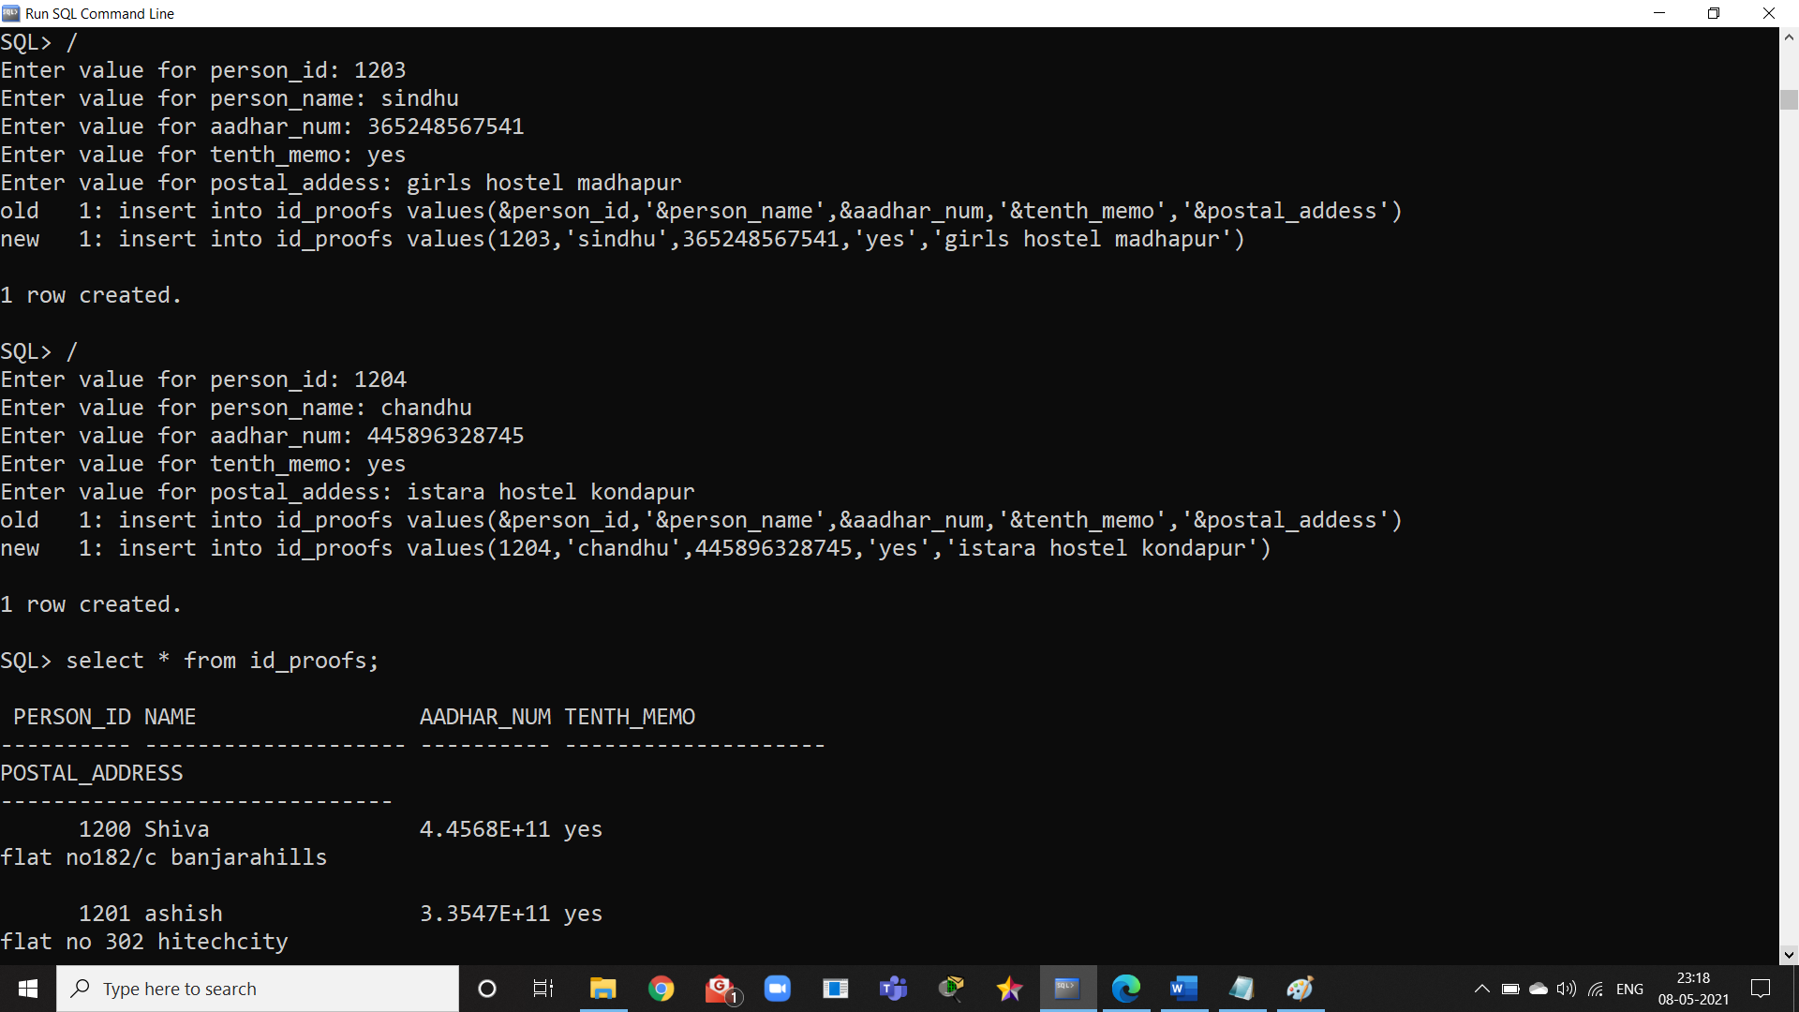

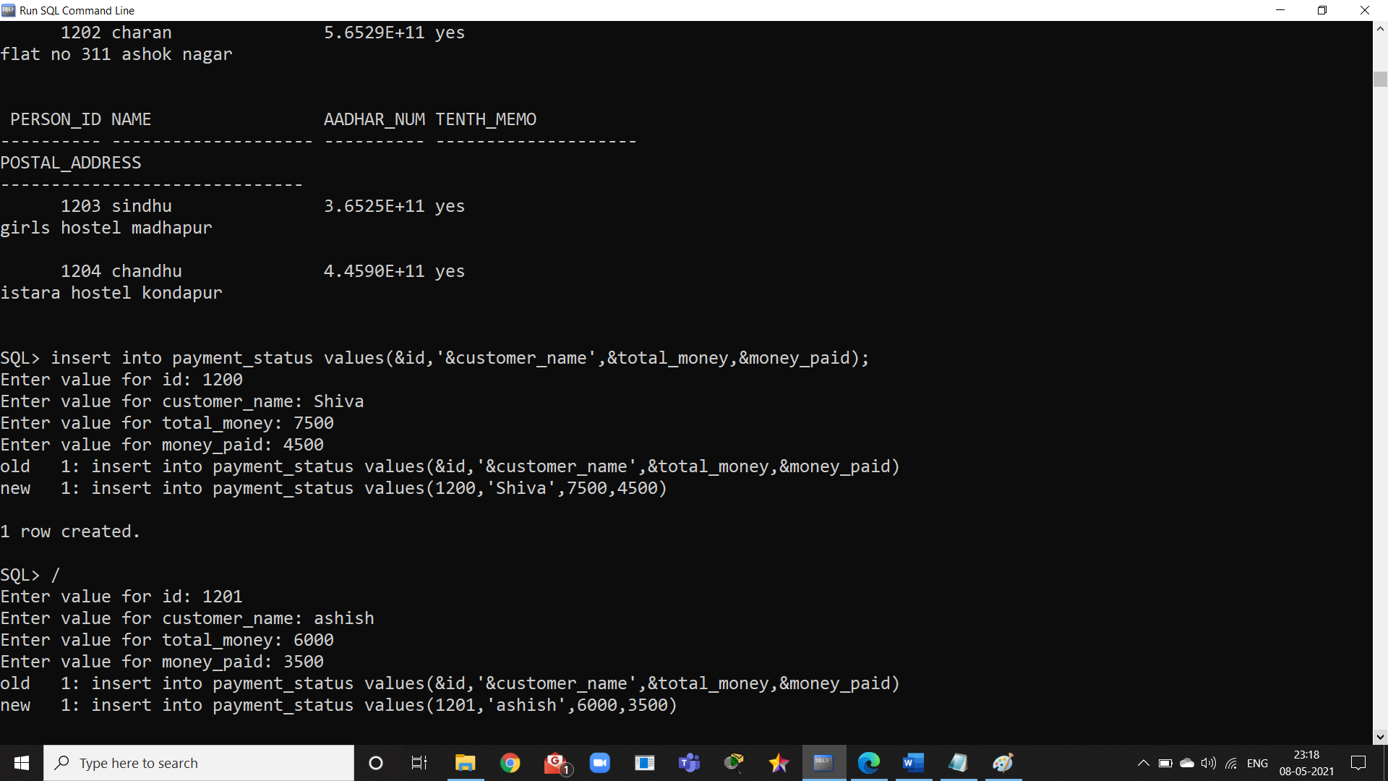

**17**

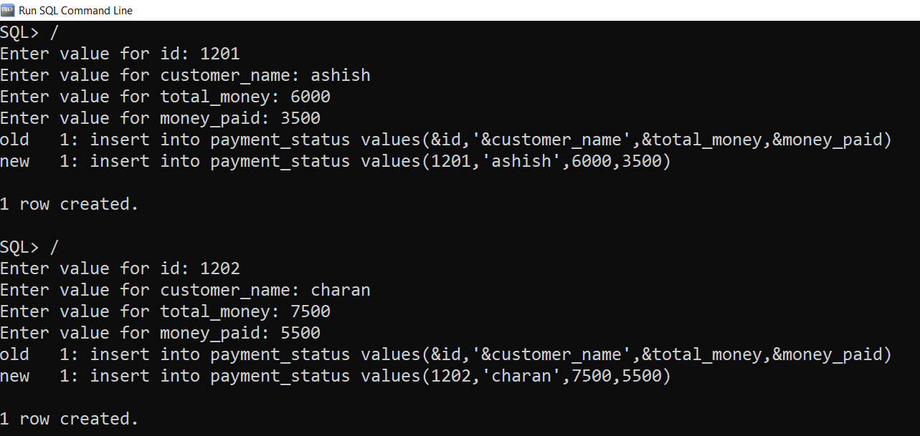

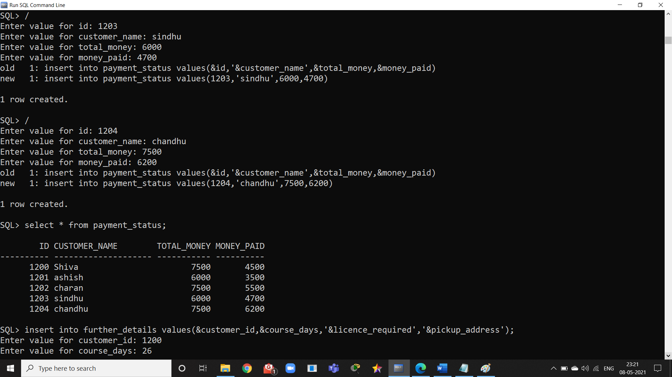

**18**

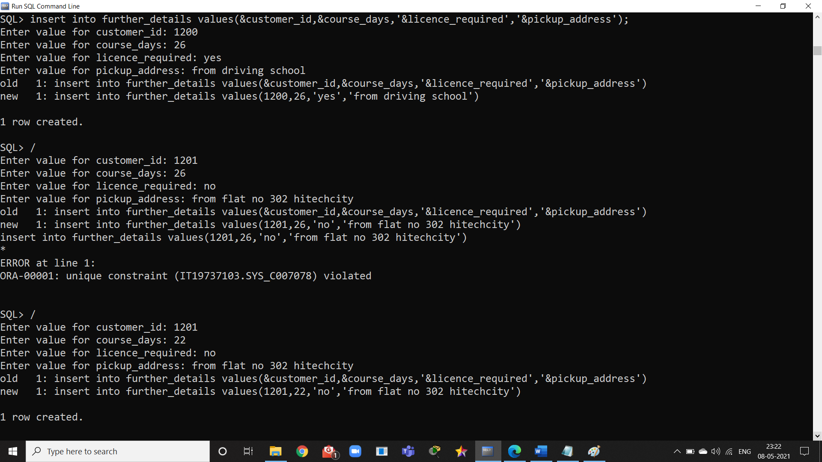

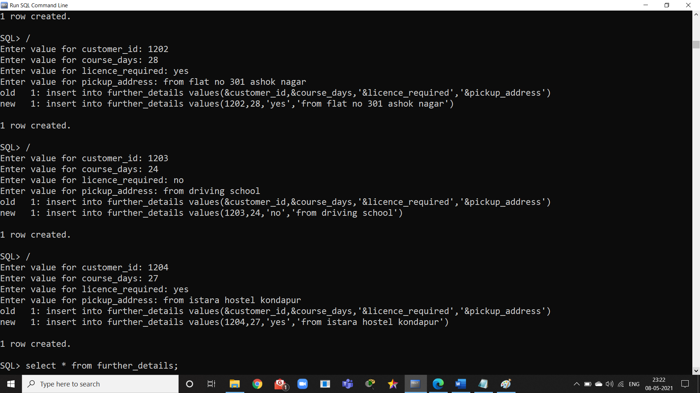

**19**

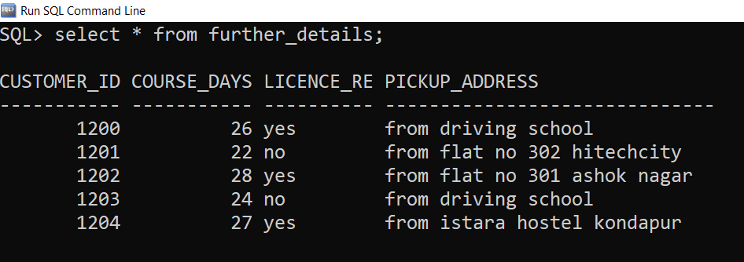

**--------------------------------------------------xxxxxxxxxxxxxxxxxxx----------------------------------------------------**

**20**